Procurement SOP

Scope: | This SOP establishes a standardized process for procurement on a construction project.
Why: | - Streamline the procurement process.  - Provide better visibility into the process and responsible parties.  - Increase time efficiency.  - Increase transparency and accountability.  - Provide the means to tarin new team members.
Users: | This Procurement SOP is to be used by Electrical Contractor Personnel involved in the procurement process (including estimators, Project Managers, Field Leaders, Pre-fab managers, Purchasing Agents, and Warehouse Managers)
Tools: | Two interactive excel tools are provided with this SOP:  - Vendor Evaluation Tool (VET): A tool designed to evaluate different vendors.  - Excess Materials Handling Tool: A tool designed to facilitate the decision-making on how to handle excess materials on a construction project.

Acronyms
E: Estimator | PA: Purchasing Agent
PM: Project Manager | V: Vendor
FL: Field Leader | W: Warehouse Manager
PR: Pre-fab Manager | S: Surplus Scrap Dealer

Notes
- Project has been awarded.
- The “Understand” and “Source” phases depend on the time available to plan for the project after award.
- “Procurement” is added as separate entity here. Could be removed or modified for organizations that don’t have a separate purchasing department.
- This format was used so that contractors can easily tweak the list of activities as well as modify the engagement of the different stakeholders.

Understand your project and materials.

Step 1: What project characteristics are present?
E | PM | FL | PR | PA | W | V | Activities
X | X | X | X | X |  |  | ☐ Hold a turnover meeting from estimating.
 | X |  |  |  |  |  | ☐ Review project scope and contract.
 | X | X |  |  |  |  | ☐ Determine if any owner specific requests are made.
 | X | X |  |  |  |  | ☐ Distinguish between performance specs and design specs.
 | X | X |  |  |  |  | ☐ Identify any constraints such as restricted site access and lay down areas.
 | X | X | X |  |  |  | ☐ Identify any challenging logistics.
 | X | X |  |  |  |  | ☐ Understand contractual relationships.
 | X |  |  | X |  |  | ☐ Understand diverse business requirements.
 | X |  |  | X |  |  | ☐ Understand federal requirements.
 | X |  |  | X |  |  | ☐ Understand warranty requirements.
 | X | X |  |  |  |  | ☐ Review the submittal process.

Step 2: What materials to procure?
E | PM | FL | PR | PA | W | V | Activities
X | X | X |  |  |  |  | ☐ Pull material requirements from the Estimate.
 | X | X |  | X |  |  | ☐ Evaluate specs for "Comply", "Deviate", and "Exclude" (C, D, E):  - Check materials in specification for "comply" – do as stated in specs; "deviate" - deviate from what is stated in the specs; and "exclude" – remove from specs.  - Specs revised for CDEs are to be sent with submittals for the engineer to approve.
 | X | X |  |  |  |  | ☐Identify hazardous materials (need to have Safety Data Sheets).
 | X | X | X |  |  |  | ☐ Identify pre-fab opportunities.
 | X | X | X | X |  | X | ☐ Identify long lead items.
 | X | X | X | X |  | X | ☐ Identify item risk level (availability, delivery, etc.).
 | X | X | X | X |  |  | ☐ Review who has the authority to order materials.
 | X | X | X | X |  |  | ☐ Consolidate a list of what to procure.

OUTCOME:
Code | Description | C, D, E | Prefab Y/N | Long lead Y/N | Risk Level
*Could connect to WBS.

Step 3: How much to procure?
E | PM | FL | PR | PA | W | V | Activities
X | X | X | X |  |  |  | ☐ Update Bill of Material (BOM) with feedback from the field.
 | X | X |  | X | X |  | ☐ Check inventory internally for available materials to avoid unnecessary purchases.
 | X | X |  | X |  | X | ☐ Check inventory externally for available materials.
 | X | X |  | X |  |  | ☐ Check BOM of other projects and consider combining POs later.
 | X | X |  | X |  |  | ☐ Determine if Bulk Buy is needed (take advantage of discounts if possible).

OUTCOME:
Code | Description | C, D, E | Prefab Y/N | Long lead Y/N | Risk Level | Quantity (available & needed) | Combine  Y/N | Bulk Buy  Y/N

Step 4: When to procure?
E | PM | FL | PR | PA | W | V | Activities
 | X |  |  |  |  |  | ☐ Connect the BOM to project schedule.
 | X | X |  | X |  |  | ☐ Discuss release dates and delivery dates (what part of the job will the materials be used).
 | X | X |  | X |  |  | ☐ Discuss when it makes the most sense to source quotes for materials.
 | X | X | X | X |  | X | ☐ Be aware of market conditions.
 | X | X |  | X |  | X | ☐ Connect with Vendors for feedback.
 | X | X |  |  |  | X | ☐ Add delivery notes.

OUTCOME:
Code | Description | C, D, E | Prefab Y/N | Long lead Y/N | Risk Level | Quantity (available & needed) | Combine  Y/N | Bulk Buy  Y/N | Delivery notes | Sourcing Timeline

Source materials

Step 5: Where to procure?

Options to choose from:
Materials are classified as commodities or major materials.
Both material groups can be procured through either blanket contract or competitive bidding.

Commodities/Blanket Contract in place
E | PM | FL | PR | PA | W | V | Activities
 | X |  |  | X |  | X | ☐ Review contract conditions.
 | X | X |  | X |  | X | ☐ Discuss storage options for bulk items.
 |  |  |  |  |  |  | ☐ Ensure blanket pricing is in line with project budget.
 | X | X |  | X |  | X | ☐ Buy commodity items under contract from the particular vendor/supplier.

Commodities/Competitive Bidding
E | PM | FL | PR | PA | W | V | Activities
 | X | X |  | X |  |  | ☐ Create potential bid list (build on the OUTCOME of the previous step).
 | X | X |  | X |  |  | ☐ Specify bid requirements (due date, information to provide with quote, delivery date, warranty & training requirements, submittal requirements, pricing break outs, etc.).
 |  |  |  | X |  |  | ☐ Create and address RFIs as needed.
 |  |  |  | X |  |  | ☐ Create RFQs.
 | X | X |  | X |  |  | ☐ Review, finalize, and send RFQs to bidders.  ☐ Include 80%-90% of original estimated material needed to avoid material surplus.
 |  |  |  |  |  | X | ☐ Submit response to RFQs (bids).
 | X |  |  | X |  |  | ☐ Analyze received bids.  **analyze bids – Vendors Evaluation Process
 | X |  |  | X |  |  | ☐ Determine negotiation strategy.  ☐ Discuss storage options for bulk items.
 | X |  |  | X |  |  | ☐ Select successful bidder.  ☐ [If needed] Down select and go through additional bid rounds.
 |  |  |  | X |  | X | ☐ Notify successful and unsuccessful bidders.
 | X |  |  | X |  |  | ☐ Set expectations: Create Performance Metrics.
 |  |  |  | X |  |  | ☐ Create and send contract.
 |  |  |  | X |  | X | ☐ Negotiate and revise contract as needed until reaching agreement on contract language.
 |  |  |  | X |  | X | ☐ Receive signed contract by vendor/supplier.
 |  |  |  | X |  |  | ☐ File certificate of insurance.
 | X | X |  | X |  |  | ☐ Be notified of the agreement.

Major Material/Competitive Bidding
E | PM | FL | PR | PA | W | V | Activities
 | X | X |  | X |  |  | ☐ Create potential bid list (build on the OUTCOME of the previous step).
 | X | X |  | X |  |  | ☐ Specify bid requirements (due date, information to provide with quote, delivery date, warranty & training requirements, submittal requirements, pricing break outs, etc.).
 |  |  |  | X |  |  | ☐ Create and address RFIs as needed.
 |  |  |  | X |  |  | ☐ Create RFQs.
 | X | X |  | X |  |  | ☐ Review, finalize, and send RFQs to bidders.
 |  |  |  |  |  | X | ☐ Submit response to RFQs (bids).
 | X |  |  | X |  |  | ☐ Analyze received bids.  **analyze bids using the Vendor Evaluation Tool (VET)
 | X |  |  | X |  |  | ☐ Determine negotiation strategy.
 | X |  |  | X |  |  | ☐ Select successful bidder.  ☐ [If needed] Down select and go through additional bid rounds.
 |  |  |  | X |  | X | ☐ Notify successful and unsuccessful bidders.
 | X |  |  | X |  |  | ☐ Set expectations: Create Performance Metrics.
 |  |  |  | X |  | X | ☐ Elaborate on warranty information and consideration for extended warranties with certified training.
 |  |  |  | X |  | X | ☐ Discuss storage options.
 |  |  |  | X |  | X | ☐ Prepare Contract and send to vendor for signature.  ☐ Negotiate Contract as needed.
 |  |  |  | X |  | X | ☐ Revise Contract as needed and send to vendor for signature.
 |  |  |  | X |  |  | ☐ Receive signed Contract.
 | X | X |  | X |  |  | ☐ Be notified of the agreement.

OUTCOME:
Code | Description | C, D, E | Prefab Y/N | Long lead Y/N | Risk Level | Quantity (available & needed) | Combine  Y/N | Bulk Buy  Y/N | Delivery notes | Sourcing Timeline | Sourcing Method | Selected Vendor(s)

Procure Materials
E | PM | FL | PR | PA | W | V | Activities
 |  |  |  |  |  |  | ☐ Create a submittal log.
 | X |  |  | X |  | X | ☐ Request submittals from vendors.  ☐ Submittals’ timeline depends on the release dates and delivery dates of the materials.
 | X |  |  | X |  | X | ☐ Receive and review submitted submittals for conformance with specs.
 | X |  |  | X |  |  | ☐ Send submittals (including CDEs if any) to GC for submission to Engineer/Owner’s Rep.
 | X |  |  | X |  | X | ☐ Revise submittals and resubmit as needed.

Execution

Material Order

Step 6: How to purchase?

Options to choose from (based on material selection from the Source phase):

Office/Centralized Procurement/Normal Process
E | PM | FL | PR | PA | W | V | Activities
 |  |  |  |  |  |  | ☐ Understand the project schedule and the delivery requirements of major items.
 | X | X |  |  |  |  | ☐ Use a two-week lookahead schedule to plan for the materials needed.
 | X | X |  |  |  |  | ☐ Prepare a material requisition form.
 | X | X | X |  |  |  | ☐ Prepare request for material release.
 | X |  |  | X |  |  | ☐ Send material requests to the purchasing department.
 |  |  |  | X |  |  | ☐ Review requests across different projects (for potential combination).
 | X |  |  | X |  |  | ☐ Review and approve requisition.
 |  |  |  | X |  |  | ☐ Create Purchase Order (PO) log
 |  |  |  | X |  |  | ☐ Create PO.  **Purchase only submitted and approved items.  **PO creation and approval may depend on the PO value.
 | X |  |  | X |  |  | ☐ Send copy of PO to PM.
 |  |  |  | X | X |  | ☐ Send PO to warehouse manager to check if surplus inventory is available (closest warehouse).
 |  |  |  |  | X |  | ☐ Check inventory for items required.
 |  |  |  |  | X |  | ☐ If inventory is to be used, send information to Procurement.
 |  |  |  |  | X |  | ☐ Update PO based on information received from the warehouse manager.
 |  |  |  | X |  |  | ☐ Send PO to vendor (per Step 5).
 |  |  |  | X |  | X | ☐ Receive acknowledgement from vendor (PO#, Terms and Conditions).  ☐ Vendor approves T&C’s as is.  ☐ Vendor proposes revisions.
 |  |  |  | X |  |  | ☐ Send notification of received acknowledgment.

Material Delivery

Step 7: Where and how to deliver?
E | PM | FL | PR | PA | W | V | Activities
 | X |  |  |  |  | X | ☐ Monitor PO status.
 |  |  |  | X |  | X | ☐ Periodically check-in with vendors to ensure delivery is on schedule.
 | X | X |  | X |  | X | ☐ Resolve delivery issues.
 | X | X |  | X |  | X | ☐ Reconfirm delivery date and logistics.
 | X | X |  | X |  | X | ☐ Receive notification from vendors prior to shipment.
 | X | X |  |  |  |  | ☐ Ensure material handling equipment is onsite to receive as necessary.
 |  |  |  |  |  | X | ☐ Ship items per PO.
 | X | X |  |  |  |  | ☐ Inspect delivery for order accuracy (type of material, quantity, and condition).
 | X | X |  |  |  | X | ☐ Document any non-conformance with vendor.
 | X | X |  |  |  |  | ☐ Refuse damaged materials.
 | X | X |  |  |  |  | ☐ Sign packing slip if there are no issues with the delivery.  ☐ For any issues with the order, sign and explain.
 | X |  |  | X |  |  | ☐ Send delivery acknowledgement to the purchasing department.  ☐ For any issues with the order, dispute with the vendor.
 |  |  |  |  |  | X | ☐ Prepare warranty and O&M documents and for closeout and schedule training (if required).
 | X |  |  | X |  | X | ☐ Receive warranty and O&M documents for closeout and perform training (if required).
 |  |  |  |  |  |  | ☐ Ensure all warranty and O&M documents have been provided and training (if required) have been performance prior to releasing full payment.
 | X |  |  |  |  |  | ☐ Send warranty and O&M documents training (if required) to customer.

Material Return

Step 8: How to return?
Material Return Flowchart
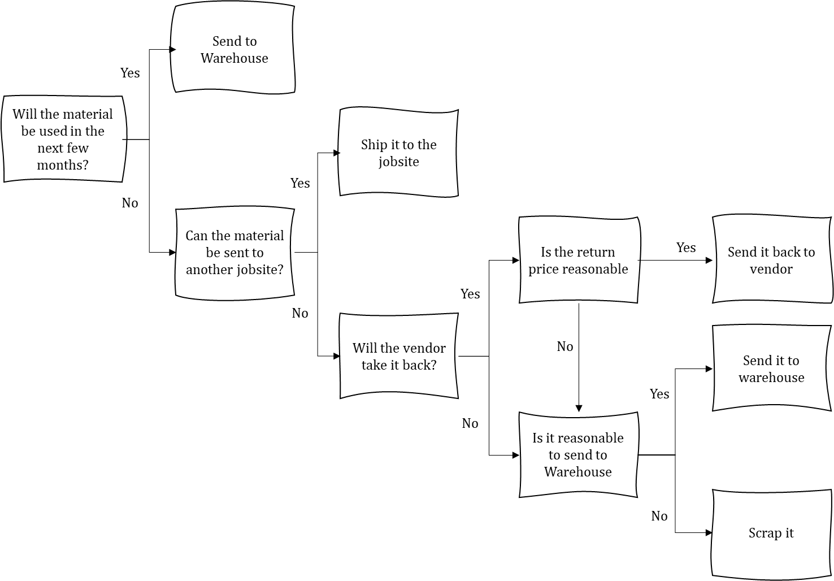
>> Download the Excess Materials Handling Tool

Jobsite returns to vendors.
E | PM | FL | PR | PA | W | V | Activities
 | X | X |  | X |  |  | ☐ Send request of material return to Procurement.
 | X | X |  | X |  |  | ☐ Send a copy of the PO to the requester to highlight the items to be returned.
 | X | X |  |  |  |  | ☐ Note the list and quantities of items to be returned on the PO and send to Procurement.  ☐ Prior to project completion and de-mobilization of the job.
 |  |  |  | X |  |  | ☐ Contact vendor to initiate the return process.
 |  |  |  |  |  | X | ☐ Verify the list of returned items.
 |  |  |  |  |  | X | ☐ Issue Return Material Authorization RMA#.  ☐ Timeline depends on the type of materials being returned (hours vs days).
 | X | X |  | X |  | X | ☐ Coordinate material pickup and timely return.  ☐ Material must be in original containers, if possible, and in re-sellable condition.
 |  |  |  | X |  | X | ☐ Receive confirmation of material pickup.

Material returns to Warehouse.
E | PM | FL | PR | PA | W | S | Activities
 | X | X |  |  |  |  | ☐ Note the list and quantities of items to be returned to the warehouse.
 | X | X |  |  |  |  | ☐ Send list to other projects and check if material can be sent there.
 | X | X |  | X |  |  | ☐ [If no project can receive the material] Evaluate your option using the flowchart and provided Excess Materials Handling Tool tool.
 | X | X |  | X |  |  | ☐ [If material to be sent to warehouse] Send list to warehouse.
 | X | X |  |  | X |  | ☐ Receive material at warehouse and send a note to all project managers and foremen.
 | X | X |  |  | X |  | ☐ Ship the newly claimed material to jobsite.
 |  |  |  |  | X |  | ☐ Divide balance of materials not claimed into sell and scrap categories.
 |  |  |  |  | X | X | ☐ Contact material surplus suppliers and negotiate best price for material to be sold.
 |  |  |  |  |  | X | ☐ Pick up surplus material from the warehouse.
 |  |  |  |  | X |  | ☐ Scrap unsold material.

Change

Step 9: How to handle changes?

Changes requested by owner or due to design issues.
E | PM | FL | PR | PA | W | V | Activities
 | X |  |  |  |  |  | ☐ Create a Change Order log.
 | X | X |  |  |  |  | ☐ Determine type of pricing (Lum sum, T&M, Unit price).
 | X | X |  |  |  |  | ☐ Outline the activities to be performance along with direct costs (labor, equipment, materials, subcontractors (if any)).
 |  |  |  |  |  |  | ☐ Send Change Order to the Customer for approval.
 | X |  |  | X |  |  | ☐ Create a separate PO for needed materials.
 |  |  |  | X | X |  | ☐ Send PO to warehouse manager to check inventory.
 |  |  |  |  |  |  | ☐ Follow same process as Step 7.

